**Sales By Channel Analysis**

**Tool: Power BI**

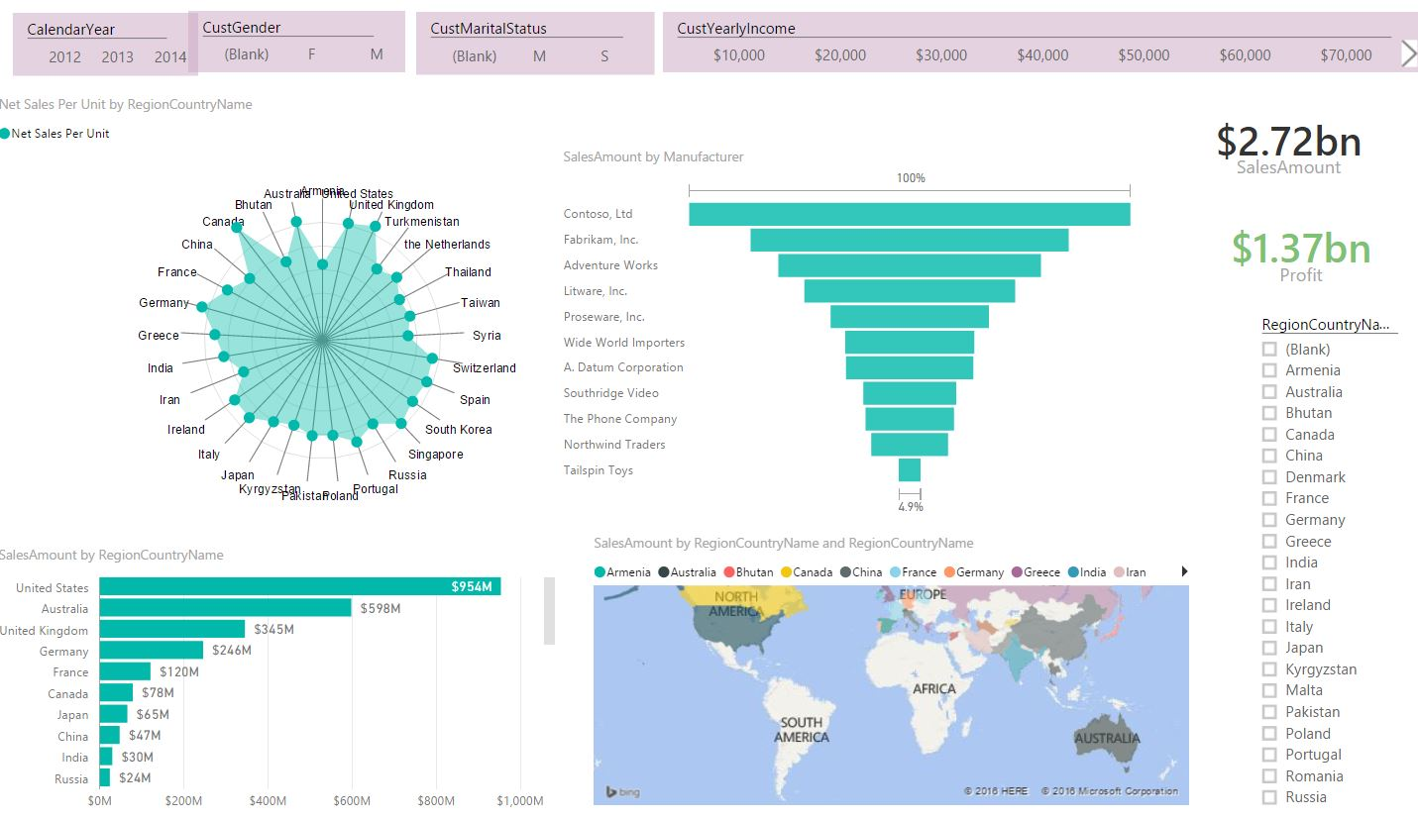

**Inventory Analysis**

**Tool: QlikSense**

